21.November 2016

**V 1.0**

**CSE 542**

Test Plan Document

# Contributors

1. Manjeet Singh
2. Sandeeep Shenoy
3. Vidhi Shah
4. Neerad Somanchi
5. Vivek Singh

# Part 1 : Unit Testing

# **Simple Loop Test:**

Junit Test Code Snippet:

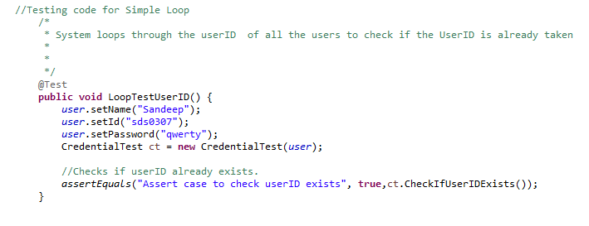

# **Boundary analysis:**

Junit Test Code Snippet:

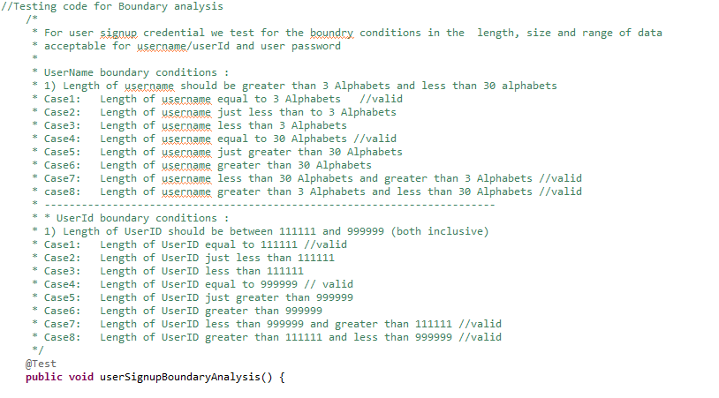

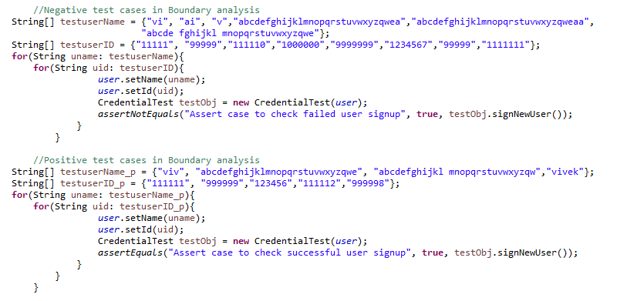

# 

# **Bad-Data**

Junit Test Code Snippet:

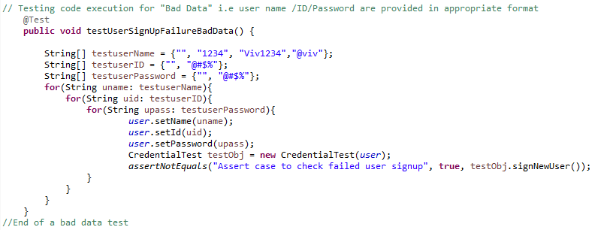

**Good-Data :**

Junit Test Code Snippet:

# 

# **All-Branch coverage:**

Junit Test Code Snippet:

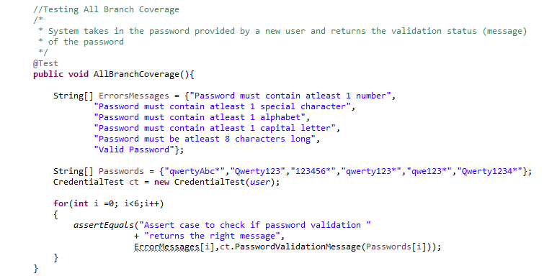

# 

# **Algorithm for All-Branch coverage:**

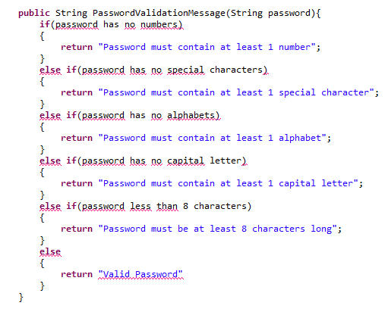

# **Explanation of the algorithm of PasswordValidationMessage () method:**

The PasswordValidationMessage () method, checks if the provided password is valid or not based on given set of condition.

Test Scenarios:

|  |  |  |
| --- | --- | --- |
| **Sl No.** | **Test Scenario** | **Expected result (returned)** |
| 1 | Entered password has no numbers | Password must contain at least 1 number |
| 2 | Entered password has no special characters | Password must contain at least 1 special character |
| 3 | Entered password has no alphabets | Password must contain at least 1 alphabet |
| 4 | Entered password has no capital letter | Password must contain at least 1 capital letter |
| 5 | Entered password less than 8 characters | Password must be at least 8 characters long |
| 6 | Enter a valid password | Valid Password |

All of the branches of PasswordValidationMessage () if else method is covered by the AllBranchCoverage Junit Test.

# 

# 

# 

# 

# 

# 

# 

# 

# 

# Integration Tests

**Integration Test 1**

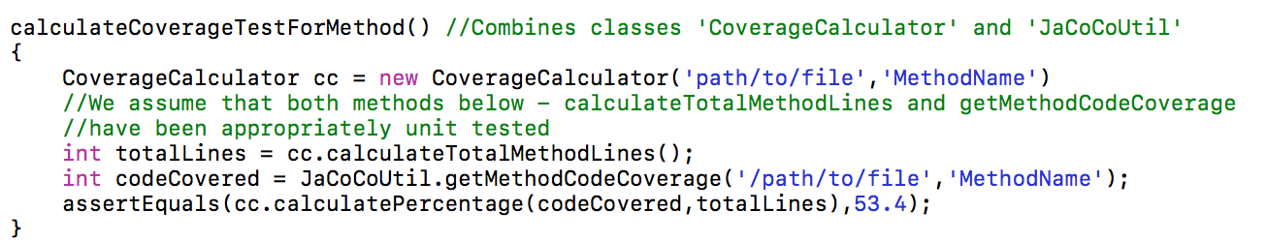

**Purpose**

Make sure calculating method coverage works

**Methods used in this test**:

calculatePercentage, calculateTotalMethodLines, getMethodCodeCoverage

**Step-by-step directions to perform this test :**

1. Call test-case ‘calculateCoverageTestForMethod()’

**Step-by-step expected results:**

1. 53.4 - (Percentage of code covered in method)

**Integration Test 2**

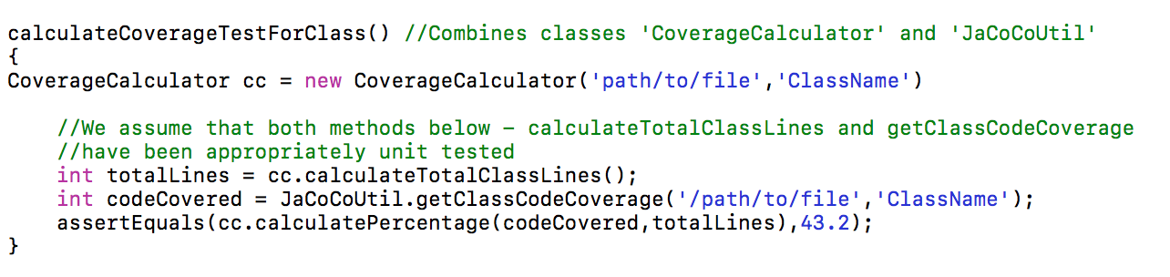

**Purpose**

Make sure calculating class coverage works

**Methods used in this test**

calculatePercentage, calculateTotalClassLines, getClassCodeCoverage

**Step-by-step directions to perform this test :**

1. Call test-case ‘calculateCoverageTestForClass()’

**Step-by-step expected results:**

1. 43.2 - (Percentage of code covered in class)

# 

# 

# Validation Tests

**Validation Test 1**

**Purpose**

Make sure calculating method coverage works

**Methods used in this test**:

calculateCodeCoverage, calculatePercentage, calculateTotalMethodLines, getMethodCodeCoverage

**Step-by-step directions to perform this test :**

1. Give the parameters filePath as ‘path/to/file’ and name as ‘TestClass’ and call calculateCodeCoverage() step by step expected results:

**Step-by-step expected results:**

1. 53.4 - (Percentage of code covered in method)

**Validation Test 2**

**Purpose**

Make sure calculating class coverage works

**Methods used in this test**

calculateCodeCoverage, calculatePercentage, calculateTotalClassLines, getClassCodeCoverage

**Step-by-step directions to perform this test :**

1. Give the parameters filePath and name and call calculateCodeCoverage() step by step expected results

**Step-by-step expected results:**

1. 43.2 - (Percentage of code covered in class)